REGRESSION:

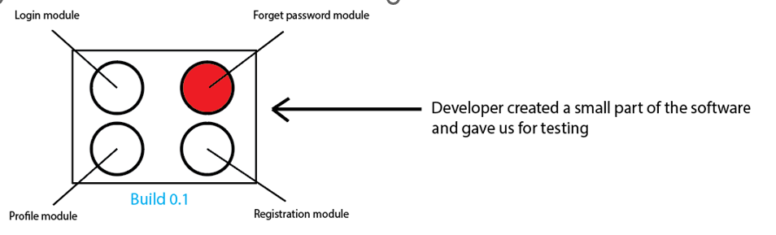
Developer created a small part of the software and gave it to us for testing is called build

Suppose we found a bug in one module, so we will report the defect/bug to the developer, and the developer will fix or modify the module to resolve it. Sometimes the developer may add a new feature or delete some feature from the application/software and release another build Build 0.2.
When the developer makes some changes to fix the module, sometimes it affects other existing modules or existing functionality, because there are connections between those modules.
A tester will have to check the new functionality, bug fixes, and changes, and also check the existing functionality to ensure they are not impacted.
This is called regression testing.
Regression Testing Involves:
- Testing the new changes to verify that the bug has been correctly fixed.
- Checking the new features added to ensure they work as intended.
- Verifying that existing functionalities remain unaffected by the recent changes.

Re testing:
Once developer fix a bug, It is testers job to check if the fix works or not. This is known as re-testing.
If the fix resolves the issue, the tester marks the bug as fixed. If not, the bug is reopened and sent back to the developer again
The aim is to verify whether problems identified in earlier versions have been successfully resolved in the latest version.

SMOKE VS SANITY
Category | Smoke Testing | Sanity Testing
Purpose | To check whether the basic and critical functionalities of the application are working and whether the build is stable enough for further testing. | To verify that a specific bug fix or small change works correctly and that related functionality is not broken.
Depth of Testing | Very shallow and wide — high-level checks only. | Narrow and deep — focused checks in a specific area.
Who Performs It | Usually QA testers. (Developers may also do a smoke check before handing the build.) | Only QA testers.
When It’s Done | After receiving a new build, before accepting it for full testing. | After a bug fix, or after a minor code change, before regression. Insufficient time before release
Scope | Covers all major, critical features. | Covers only the changed or related components.
Goal | “Is the build OK to proceed?” | “Is this specific fix or feature working properly?”
Documentation | Test cases may be predefined (smoke test suite). | Usually not scripted — quick, focused testing.

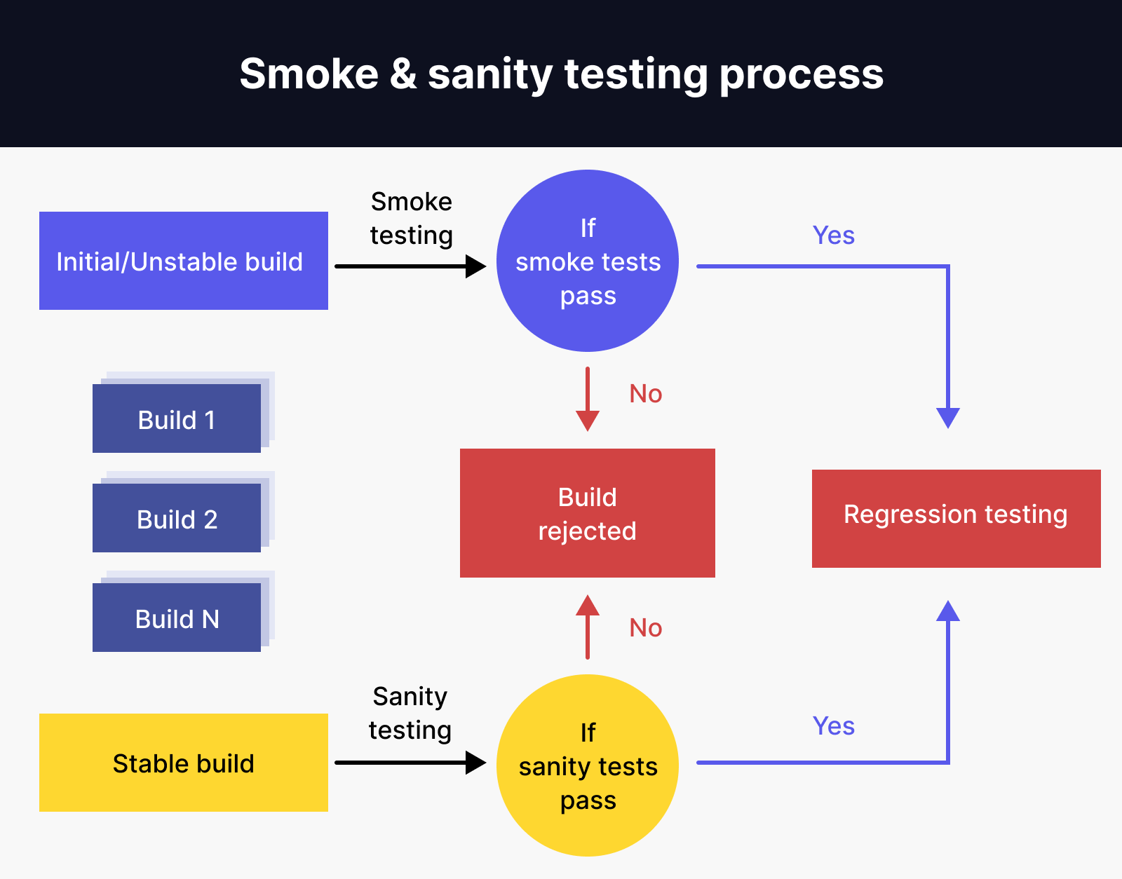
Phase | Activities | What is made
Test Planning | - Identify testing scope  - Estimate effort & timelines  - Identify required resources  - Define test strategy & tools  - Prepare Test Plan  - Review & approve Test Plan  Test Manager / QA Manager (70%) - Test Lead (30%) | Test Plan Document
Test Design | - Identify test conditions  - Prepare Test Scenarios  - Design Test Cases & Test Data  - Prepare Traceability Matrix (RTM)  - Review & approve Test Cases  Test Lead (30%) - Test Engineers (70%) | Test Scenarios  Test Cases  Traceability Matrix
Test Execution | - Execute Test Cases  - Log actual results  - Report defects –  - Retest fixed defects  - Perform Regression Testing  Test Engineers (90%) - Test Lead (10%) | Test Execution Report  Defect Reports
Defect Reporting & Tracking | - Create Defect Reports  - Assign severity & priority  - Track defect through lifecycle  - Coordinate with developers  Test Engineers (90%) - Test Lead (10%) | Updated Defect Log
Test Closure  Sign-Off | - Evaluate test completion criteria  - Create Test Summary Report  - Document lessons learned - Final sign-off meeting  Test Manager / Test Lead (70%) - QA Engineers (30%) | Test Summary Report  Test Closure Report

