Class 03 Hand out

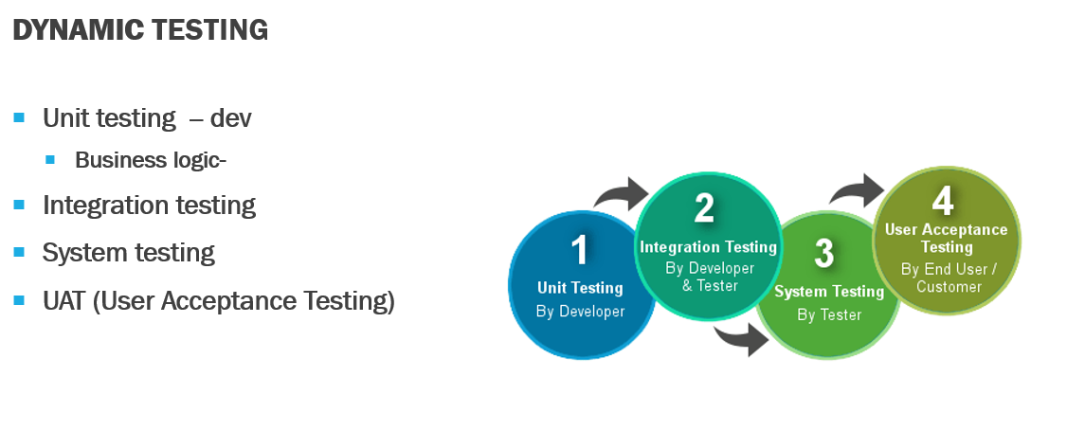

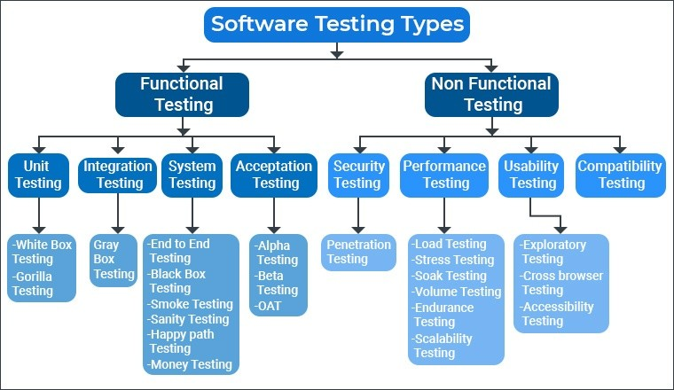

Functional & General Testing
End-to-End Testing
Checking the software for a workflow from start to finish as a real user would, making sure all connected parts work together.
Example For Netflix:
Workflow:
Sign in → Search movie → Play → Add to My List → Log out
This is End-to-End, even though you’re not testing Signup, Payments, Kids Profile, etc.

Black Box Testing
Testing the system without knowing its internal code — only checking inputs and outputs.
Smoke Testing
A quick basic check to see if the important features are working enough for deeper testing. We also call it build test
Sanity Testing
A small focused test to confirm a specific bug is fixed or a small change works.
Happy Path Testing
Testing the application thinking we are doing everything correctly all positive.

Alpha Testing
Testing done internally by company employees before giving it to customers.
Beta Testing
Testing done by selected real users before the official release.
Penetration Testing
Trying to hack the system like an attacker to find security holes.
Performance Testing

Load Testing
Checking how the system performs with expected number of users.
Stress Testing
Testing the system with beyond expected users to see when it breaks.
Soak Testing
Running the system for a long time to see if it slows down or leaks memory.
Volume Testing
Testing with a huge amount of data (big files, many records).
Endurance Testing
Similar to soak testing — checking system performance over long continuous use.
Scalability Testing
Checking how well the system grows when more users or servers are added.

Exploratory Testing
Testing freely without scripts to discover issues through creativity and experience.
Cross-Browser Testing
Checking if the website works correctly across different browsers like Chrome, Safari, Edge.
Accessibility Testing
Checking if the app can be used by people with disabilities (screen readers, keyboard only, color contrast, etc.).

1. Authentication & User Management Module
US-101: User Login
As a registered user,
I want to log in using my email and password,
so that I can access my Netflix account.
US-102: User Logout
As a logged-in user,
I want to log out from my account,
so that I can stop others from accessing my profile.
US-103: User Sign-Up
As a new user,
I want to create an account,
so that I can start using Netflix.
US-104: Forgot Password
As a user who forgot my password,
I want to reset it using email verification,
so that I can log back into my account.
US-105: Select Profile
As a user with multiple profiles,
I want to select my personal profile,
so that I can watch my personalized content.
US-106: Kids Profile
As a parent,
I want to restrict my kids to a kids-only profile,
so that they only see age-appropriate content.
US-107: Switch Accounts
As a user,
I want to switch between different profiles easily,
so that each person can use their own preferences.

2. Home Page / Dashboard Module
US-201: View Home Page
As a user,
I want to see personalized recommendations on the home page,
so that I can quickly find something to watch.
US-202: Continue Watching
As a returning user,
I want to continue watching a title from where I left off,
so that I don’t have to search again.
US-203: Browse Genres
As a user,
I want to browse movies and shows by genre,
so that I can easily find content I’m interested in.
US-204: View Trending Titles
As a user,
I want to see the top trending titles,
so that I know what’s popular.

3. Search Module
US-301: Search for Content
As a user,
I want to search for movies, shows, actors, and genres,
so that I can quickly find content.
US-302: Live Suggestions
As a user,
I want to see suggestions while typing,
so that I can find results faster.
US-303: Voice Search (Mobile/TV)
As a mobile or TV user,
I want to use voice search,
so that I can search hands-free.
US-304: View Search Results
As a user,
I want to see a sorted results page,
so that I can choose the best match.

