Class 02 Handout
- Stakeholders:
  - Product Owner: Define the product vision and requirements
  - Developer: Build and maintain the software.
  - QA Testers: Ensure the software meets quality standards.
  - Project Managers: Oversee the development process and ensure timelines and budgets are met.
  - End Users: Ultimately use the software and provide feedback.
- Production Environment: https://rabbishakir.com
- Dev Environment: https://dev.rabbishakir.com
- QA Environment / Test Environment: https:// qa . rabbishakir.com
- qa.rabbishakir.com

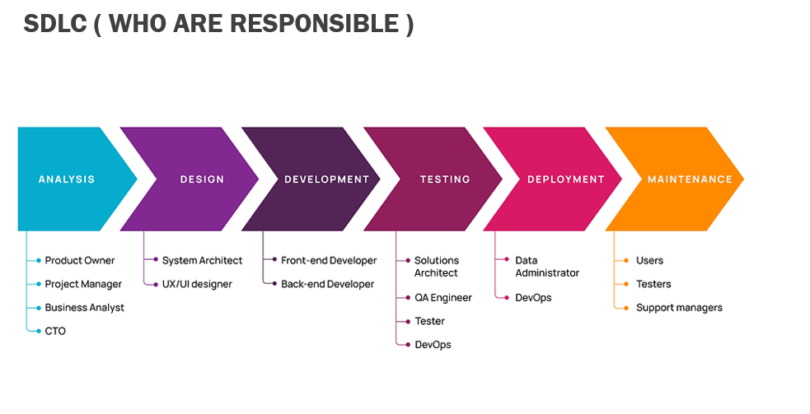
How Web Technology Works
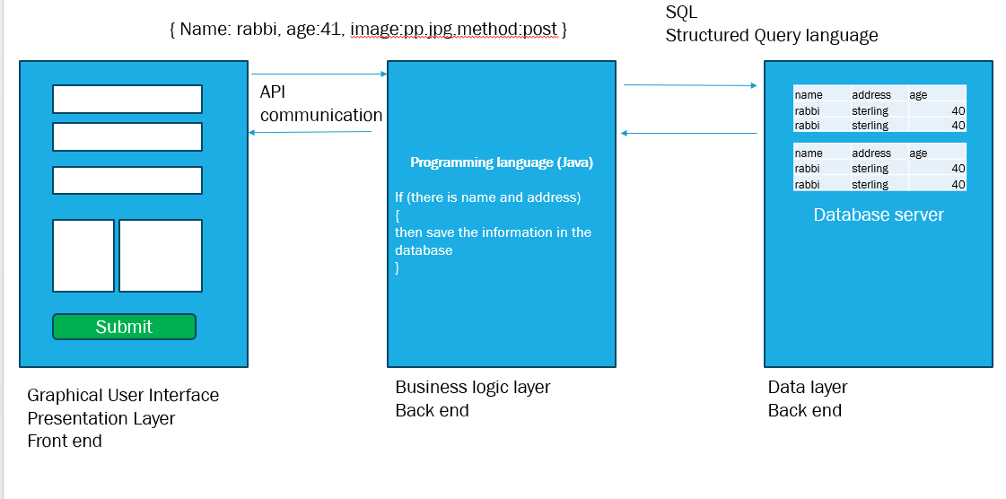
From Requirement to Mockup
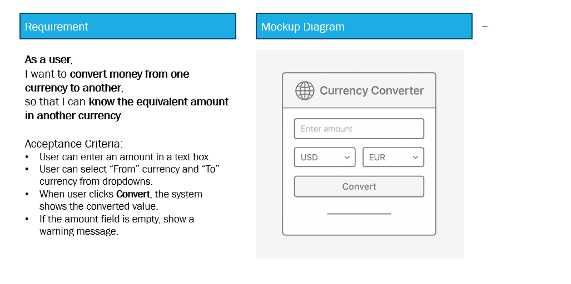

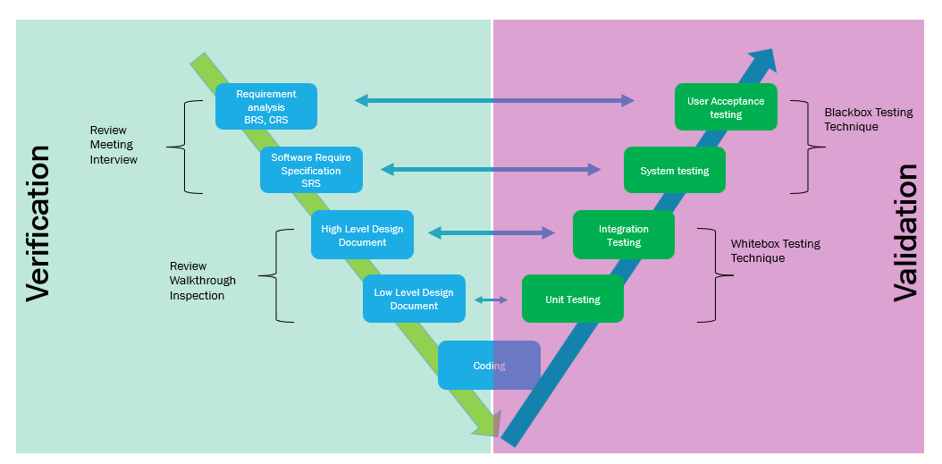

Type of Testing
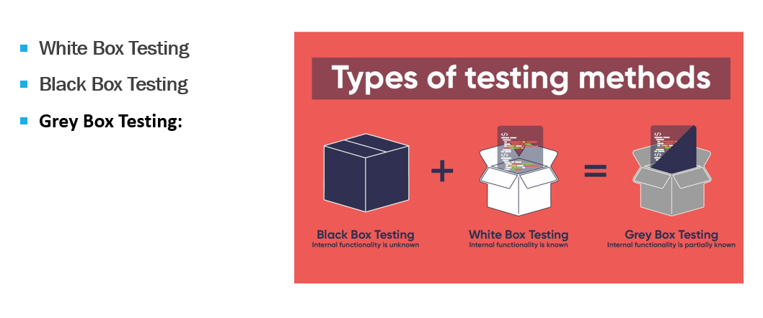

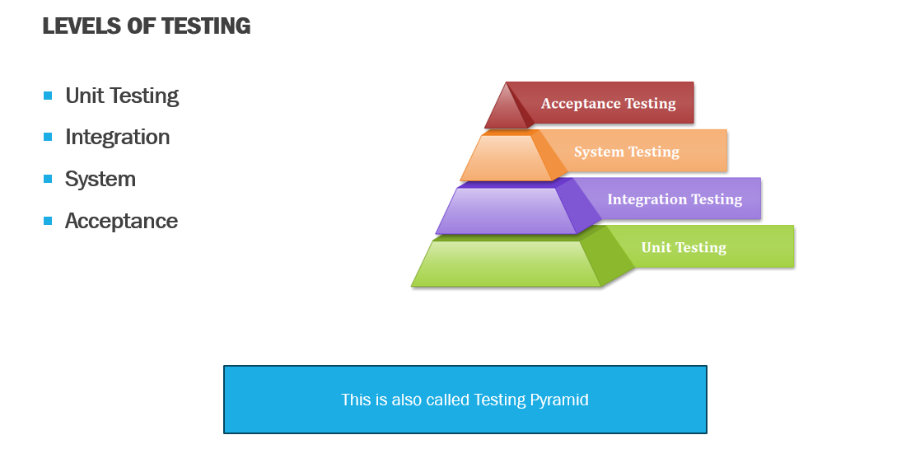

🧾 User Story
As a house owner
I need to install a door in my house
So that nobody can enter without permission, and I can enter and exit safely.

✅ Acceptance Criteria
- The door should be made of wood
- The door should be white in color
- It must have a lock
- It must have a camera
- It should have a knock handle
- It should have a peephole
- It should open and close smoothly
- It should not make any sound while opening or closing
- It should be 6 feet in height
- It should have a functional door knob

🧪 Test Scenarios and Test Cases
Test Case ID | Test Scenario | Test Steps | Expected Result
TC_01 | Verify door material | Inspect door material type | Door is made of wood
TC_02 | Verify door color | Visually check the door color | Door is white in color
TC_03 | Verify lock mechanism | Lock and unlock the door | Lock and unlock functions work correctly
TC_04 | Verify camera presence | Check for camera and test recording | Camera is present and functional
TC_05 | Verify door knock handle | Knock 5 times on handle | Audible knocking sound is heard
TC_06 | Verify peephole | Look through peephole | Outside view is clearly visible
TC_07 | Verify opening and closing | Open and close door several times | Door opens and closes smoothly
TC_08 | Verify noise level | Open and close door 5 times | Door operates quietly without noise
TC_09 | Verify door height | Measure from bottom to top | Door height is exactly 6 feet
TC_10 | Verify door knob functionality | Check for knob and rotate it | Door knob is present and functional

